Lab 5

Procedure: Capacitance in Series
- Record the measured capacitances in data table 1.
- Connect two capacitors in series
- Measure the total capacitance of the combination and write in data table 1.
- Leave the series arrangement intact and discharge the capacitors one at a time.
- Connect with dc source.
- Measure voltage across each capacitor and record in data table 1.
- Measure the voltage across the combination and record it in data table 1.
- Using the measured value of capacitances and voltages, find the charge stored on each capacitor. Record in data table 1.
- Use measured value for total voltage and capacitance. Calculate charge in the series arrangement. Record in data table 1.
- Using measured values of capacitances, find energy stored in each capacitor and the combination and record in data table 1.
- Calculate the theoretical capacitance of the series combination and record this on worksheet.
- Calculate percent difference and record it in data table 1.
- Calculate theoretical voltage and record on worksheet.
- Calculate percent difference between theoretical and measured value and record in work sheet.

Exercise

Task1: Fill the following table

Table: 1 Capacitors in Series:

Calculate the theoretical equivalent capacitance for the two capacitors in series.
 | C1 (Larger Capacitance) | C2 (Smaller Capacitance) | Total Capacitance
C_{Cal (}(µF) | 100 | 50 | 33.333
Cmeas (µF) | 98.3 | 54 | 34.85
ΔV (v) | 1.66V | 3.333V | 5V
Qcalc (µC) | 166.665 | 166.665 | 166.665
Ecalc (µJ) | 277.225 | 137.78 | 416.6625
percent difference in theoretical and measured capacitance | -1.7% | 8% | 1.01%
percent difference in theoretical and measured Voltages | -0.03% | 6.17% | 4.39%

Design of Capacitors in Series on Multisim
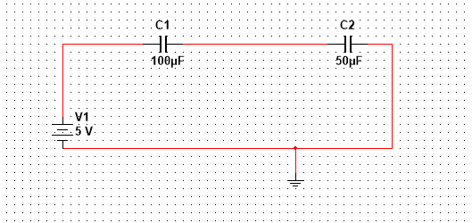

Capacitance and Voltages calculated Manually
